EXPERIMENT – 1

1. Perform basic Image Handling and processing operations on the image is to read an image in python and Convert an Image to Gray-scale.
Aim
To read an image using Python and OpenCV, and convert the image from color format to grayscale.
Procedure
- Import the OpenCV library using cv2.
- Read the input image using the cv2.imread() function.
- Check whether the image has been loaded successfully.
- Convert the color image into grayscale using cv2.cvtColor().
- Display the original image and the grayscale image using cv2.imshow().
- Wait for a key press using cv2.waitKey().
- Close all the displayed windows using cv2.destroyAllWindows().
Program
import cv2

image = cv2.imread("image.jpg")

if image is None:
print("Image not found!")
else:
gray = cv2.cvtColor(image, cv2.COLOR_BGR2GRAY)

cv2.imshow("Original Image", image)
cv2.imshow("Grayscale Image", gray)

cv2.waitKey(0)
cv2.destroyAllWindows()

Sample Input
Input image: image.jpg
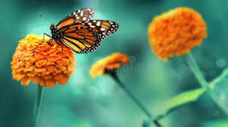
Sample Output:
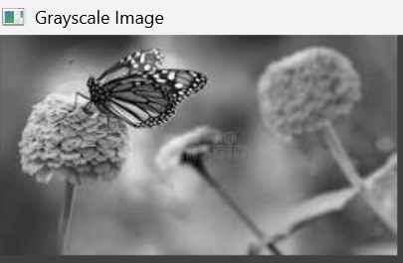
Result
Thus, the image was successfully read using Python and OpenCV and converted from a color image to a grayscale image.

